American Express Strategy Implementation
[Name]
[Institution Affiliation]
[Course]
[Date]

Communicating the mission and vision of American Express
AmEx has always been in a race to attempt to portray itself as a premium credit card company to make it easier, convenient and safe for consumers to make transactions for goods and service. AmEx seeks to maximize customer value in the credit card business while aligning this to its mission and vision. Its mission statement is to provide outstanding products and unsurpassed service that, together deliver premium value to others. Its vision statement is “to ensure our customers receive massive rewards in life”.
Historically, AmEx interchange rates have been high. This has been linked to a logic that majority of AmEx cardholder have high incomes and as a result, they possess high spending habits. Interchange is significant for AmEx, just like any other card issuer in that it helps elevate the growth of the payment system. The interchange fees act as an incentive to the issuer motivating them to issue more cards to their holders, (Credit card news 2014). It also helps cater to the risks involved in the issuance of these cards. If AmEx added more cardholders, this would also raise the benefits that merchants who accept its cards gain. A lot of resources could be put together to make the ability of these three strategies a reality.
Environmental Volatility
These factors relating to the external environment around AmEx still matter. These factors could also determine the success of the entire corporation and such new strategies. They include
The political environment and legal regulations
These two seem to go hand in hand in the case of the plastic cards industry. The politics of America and its legal framework govern and control the operations of the industry. In case a credit crisis struck, governments and legal regulators take charge, they regulate and strengthen consumer protections and enhance the idea of responsible lending. AmEx, therefore, is highly dependent on these two factors.
Economic factors
These would include interest rates and inflation. High-interest rates have an effect on how consumers access to credit. Their monthly credit card payments are likely to shoot while merchants face a rise in costs involved in financing their payrolls (Grant 2016). High inflation would also result in high interest rates. Banks would require high rates when it comes to offsetting a decline in the purchasing power from the money paid off by the borrower.
Social factors.
These would include money. It remains to be the very social issue of concern to consumers when it comes to acquiring goods and services. The current state of economic impacts on every individual thereby influencing their attitude towards cash management and issues of individual finance.
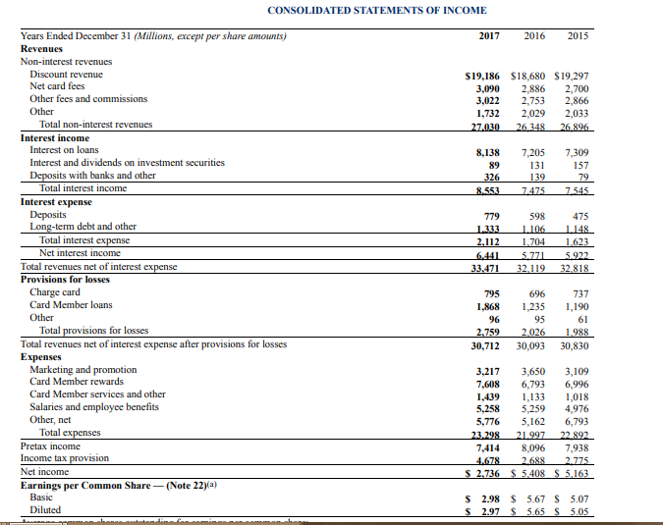
AmEx stock analysis and performance against competitors.
From the past eighteen months, the number of Amex cards circulating in accordance to the WalletHub data was around 45.7 million. This is incomparable to those of MasterCard standing at about 200 million and those of Visa at about 335 million. These are the two main competitors of AmEx. Analysts have found how explosive the nature of these three stocks is Visa and MasterCard stocks at NYSE seem to be doing great and impressive. AmEx, on the other hand, is somehow low. Visa stocks traded at around 26 times and those of MasterCard at 28 times earnings estimated. Those of AmEx trades at about 12.7 times earnings estimated. There is still more AmEx could do. The profits at Visa usually hit to about 40%, 31% at MasterCard and less than 9% at AmEx. There is definitely a reason why the two giants do business at premiums while Amex trades at a discount.
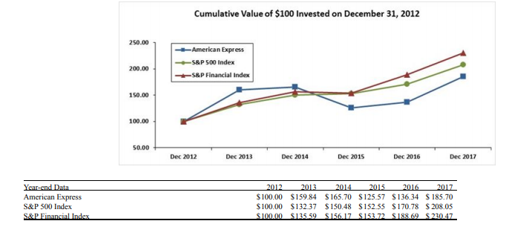
Strategy Implementation Plan
There are three proposed strategies that AmEx could adapt to realize its potential in becoming the premium credit card issuer and making the cashless payment method even easier for any customer. This is also in an attempt to realize its mission and vision and above all remain competitive in the industry. These three strategies are;
- Lowering interchange fees
- Competing with other technology, (Ex. Apple Pay)
- Millennial Issues.
Lowering Interchange Fees
In lowering interchange fees, several resources could be impacted to make this possible. Several little things could be put together to ensure lower interchange costs whenever merchants are accepting AmEx credit cards from their users. These are some of the resources that could be impacted to make it possible to lower its interchange fees.

Adoption of credit card verification service.
An address verification service is the use of a system to confirm and verify the customers’ billing address against that of the issuer. This system is important in detecting fraud in the course of the transaction. It plays a big role in the card-not-present world. Very few people are aware that this could be a cost saver technique. Credit card companies such as Visa and MasterCard apply this system worldwide which has played a big role in the success of these two in business. AmEx can also adopt this to make a step forward towards these two giants and enhance competition. AmEx could enhance this by lowering the interchange rates every time one undergoes the AVS verification during a transaction. For instance, in the case of Visa, without undergoing the AVS verification process, the charges of a credit card would be 2.30+$0.10. After undergoing the verification, the charges would decrease to as low as 1.8%+ $0.10. That would be close to fifty basis points saved on an interchange.
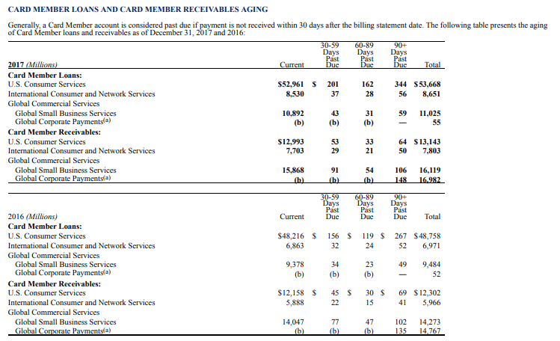

Fast handling of transactions

AmEx could work on handling transactions fast becomes a good way to reduce downgrades in the interchange. The clearing call is pursued not later than a day of authorization to getting qualified for the lowest interchange rates. Exceptions could only be made for some travel and entertainment businesses which are not supposed to be later than eight days. For most US cards, the capture (clearing call) must happen within one day of the authorization to qualifying for the lowest interchange rates, except for certain travel and entertainment businesses, which can be captured within eight days.

Verify customer info through the merchant for transactions
In conducting card-not-present transactions, some information on identity should be sent by merchants to a verification system at AmEx to clarify identity information about the transaction. Such information to include could be email addresses or URL. This should reflect in the cardholder's account. This will prevent fraudulent situations especially in online purchases and help the customer clarify how much they paid and to whom. It will also give the customer direction on whom to approach in case of a problem. If this information is not available, the transaction is downgraded.

Include transaction-specific data
Some merchants may send more transaction details to minimize interchange rate. If AmEx is pursuing a business in the business working with its clients, instead of the customers, transaction-level details can be submitted. This could be the line of the item information and the tax included so as to meet level two to three qualifications of interchange rates.

Avoid manual entering of credit card details
In any possible situation, especially during the point of sale scenario, the credit card details should not be fed manually. Instead of swiping the card or applying the chip-and-pin entry system is the best. This enhances the security processes of the store as well as earning a lower interchange rate.
To maintain competition, AmEx could put together some resources to beat other credit card competitors in the market such as Apple Pay.
The Shift to Digital/Mobile Payments
The immense use of digital and mobile money payment methods has led to a fall in the number of consumers swiping in conducting their transactions and even the use of cash. The use of mobile money payments seems to continue at a fast rate and therefore American Express needs to focus on customizing its services to fit in services that would require consumers to choose to make payments. Therefore, partnering with other businesses such as taxi and Air travel companies would suit this strategy. This would make it easy for consumers to pay for such services using the Amex credit cards. Secondly, such businesses as taxi are growing at a steady rate in that particular industry and have significantly changed the method of payments for services by their consumers. AmEx should, therefore, change its business operating model to suit in such businesses in making payments possible and, therefore, ensure value even if the technological change landscape is still heightening.
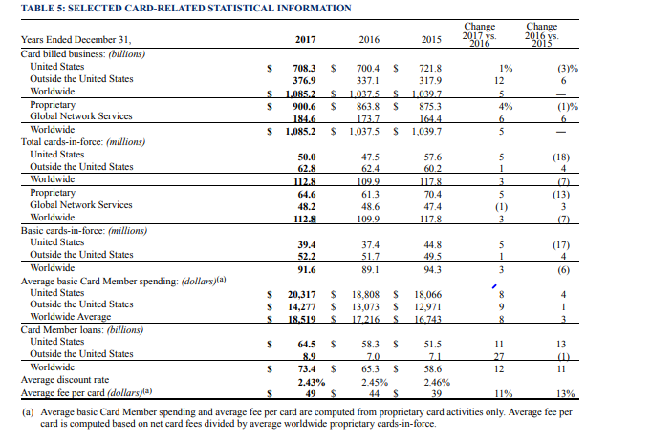
A Changing Competitive Landscape
The steady change in the competitive landscape has not only revolutionized the way people make payments; it has also altered the individual competitive landscape for AmEx. More and more alternative methods of payments such as Apple Pay and Square keep rising. This stands as a challenging balance for AmEx since others like Apple Pay serve as its revenue source and at the same time as competitors. Apple Pay and Square would enhance the number of transactions for AmEx, therefore adopting partnerships with AmEx to find compatibility techniques for both platforms is not such a bad idea. This could be a tricky step which requires much effort to balance for AmEx. The benefits that AmEx could gain from such a partnership in such a platform would probably be much than the costs incurred if they chose to remain Apple Pay’s competitors. However, AmEx needs to conduct reassessment every now and then to maintain this balance on an ongoing basis
Leveraging the Closed Loop System
Artificial intelligence and other digital technologies such as machine learning keep evolving every day. Machine learning g has enabled different digital transformations such as voice and facial recognition. Amex could integrate such systems to make it possible to leverage information and data from its closed loop system. Being in a position to offer its own cards to consumers, it is not necessary for AmEx to enter into partnerships with an issuing bank. Therefore, creating its own closed loop system whereby, it serves as its own issuer and manages the network payment can highly support its attempts to integrate technology to beat competitors. This would make them different from other creditor business competitors.
Even if its business model doe does not evolve due to changes in technology, the company’s capacity to leverage this closed-loop system will definitely have. AmEx has so far integrated machine to counter fraud through detecting suspicious transactions and make comparisons against the latest dataset. This would also enhance their customer experience by customizing real-time coupons dependent on the location of the customer at the moment.
Risks and Opportunities
Security remains to be the topmost issue of concern in the credit card business. From a report published earlier this year, 60% of merchants confirm to have experienced fraud in the course of business o online sales. 25% of them confirm that the levels have risen from last year. In as much as AmEx looks to elevate innovation, it should take a closer look at peer-to-peer payment arena where the company does not process a product apparently. The company should also look into extending its capacity to leverage data generated from its closed loop system. AmEx is attempting to catch up with the technological change landscape. However, its success will remain dependent on the capacity to innovate new systems every day while still balancing through customer value and protection from fraud and any other security threats.
In an attempt to connect with the millennials and keep up with the millennials. Such actions could be:
Offering value that’s easy to access
Millennials seem to be very much budget-conscious. This probably is because of their stage life. Usually, they have a low accumulation of assets. They also have a much lower income than those in Generation X. Therefore, they have to stretch their dollars when possible. As a result, if AmEx offered credit cards without annual charges for rewards, it would be a suitable ideal for this millennials. This would, however, work only if these rewards are easily earned and redeemable. The fact that millennials are usually value-based.
The easier it is to redeem those points, the more it drives the redemption rate. In terms of simplicity, more options stand in place. Citi Double, for instance, gives 1% back of all purchases made and the same once they are paid off. Many users of the modern cards including AmEx are millennials. About eight million users are aged between twenty-five and thirty-four. More research by Veto confirms that the users ranging from eighteen to twenty-four years’ range are about 4.5 million.
Providing unique experiences
AmEx could consider widening its payment cards into unique scenarios that catch the attention of young people. Concerts, for instance, are usually for the young. It could offer exclusive access to create a much bigger luxury. The company could partner with common music and other forms of entertainment platforms, say coke studio, tomorrow land and Coachella to offer qualifies cardholders’ unique experiences such as free taxi rides with companies such as free dinners and hair and makeup makeover. This could be work especially for those with the platinum AmEx cards. This would attract Millennials at a higher rate and boost AmEx efforts to address its millennial issues.
Collaborating with retailers who millennials love.
Amex being a card issuer could consider working with retailers who have already won the attention of millennials in shopping. They could consider giving more perks or developing new co-branded cards. The National Coffee Association confirms that a good number of millennials, aged between nineteen to thirty-four take coffee more compared to any other demographic group. AmEx could consider partnering with large coffee companies such as Tully’s coffee in an attempt to win over the millennials. They could
This could be free drinks or even food. GlobalWebIndex last year published a report that about 76% of millennials exercise at least once a week. They range from twenty-one to thirty-four years. Such a group of people would be interested in perks like in a Soul Cycle, Equinox Fitness or Barry’s Bootcamp. This would significantly work for cardholders of the Platinum card from AmEx. A good number of riders with Uber are also millennials below thirty-four years. AmEx could also consider introducing an AmEx Uber card. This could offer points on perhaps, say five dollars spent on dinner, four on booking hotels and maybe three for any online purchases like Uber. Perhaps a dollar on every other thing.
A Qualitative Impact of the Three Strategies.
AmEx could experience different impacts from the implementation of these three strategies. These are:

Impacts of low interchange rates
Lower interchange rates would definitely result to lower transaction costs. These should, in turn, be a benefit passed on to the consumer. The plan would also give a rise to more businesses beginning to accept the AmEx cards. However, if more merchants do t start accepting the Amex cards, credit card rewards could probably take a hit. Having the merchant fee drop, reward spending would, in turn, a bigger chunk of the whole revenue. This may force AmEx to slice some of its perks. However, this would only impact on the transaction costs of the credit card. Those of the debit card would still rise.
Impacts of use of technology
- Evolution of Commerce
Amex is working toward maintaining competition as for share of mind rather than just being a share of wallet. This is because there could be many more payment methods beyond plastic. There are more than $125 trillion methods of payments worldwide whereby the plastic method of payment only penetrates 15% of the whole global payment. It penetrates only 30% of the US payments.
This would not mean AmEx is trying to become more innovative only to run after a share of mind. Digital wallets seem to have been highly touted about 3 years ago but still could not catch on the highly sizeable investments in technology and marketing outlays simply because they could not solve friction points for consumers. AmEx could continue to explore the forms of factors they consumers would show interest in going forward. That would, therefore, involve exploring viable deals with other payment solutions like Samsung and Apple. The company, however, would never expose any of its crucial data in process details to its customers.
The efforts to struggle and work towards a share of mind make a lot of sense as the company focuses on navigating global improvement on how consumers can make payments for goods and services. However, there is still the agony of feeding credit card details into system portals, for instance in a new site or later after a consumer’s card is reissued following a fraudulent issue. This definitely highlights the presence of a form factor ad more so a technological integration issue that requires an address. This would have many impacts on the issuer and the networks.
If it was agony-free to update or enter a card in such a portal, consumers would definitely make cards the default method of payment. It would also favour merchants who experience high costs of cart abandonment online. AmEx Membership Points are such a solution to such technical issues online. However bigger platforms like PayPal have revolutionized commerce in a greater manner which saves consumers and merchants such problems online. AmEx could be a part of the great upcoming battle of desktop against mobile payments that will involve card issuers, technology companies, online networks and merchants.
- Data and analytics
Extensive use of technology would mean better performance in business especially from countering suspicious and fraudulent events, data management and more so enhancing customer service. Ii would mean keeping up with the fast growth in technology to reach the pace at which Visa and MasterCard are currently moving at in relation to technological innovation. In enhancing customer service, this would be out of attempts to manage consumer’s data and exercising leverage with banks and other tech companies to enhance competition

Data is the central part of AmEx. Therefore, contemplating clearly how to handle data and analytics is very important for everybody at AmEx. These two are the major drivers of information management and the security. They play a key role in the development and refining of real-time fraud and clearing of authorization. They also play a major role in credit scoring models. Those three are the drivers of the forward business model and risk mitigation, (Wilson2017). In maintaining its customer experience, AmEx could gather high texture user data and use it to establish relationships and provide good customer service at a straight one-on-one level. Such an ability to gather data on a consumer and use it to enhance improvement on customer service is quite a usual thing for tech firms.
This is the technique some firms such as Facebook and Amazon utilize. This is how Facebook and Amazon thrive. AmEx still has a big way to go before reaching that point where they can offer such customer service at the level of the large tech firms. AmEx could, as a result, link up with larger tech firms and connect its customer data to the firms and allow for instance Mint or Betterment users to access their bank accounts. Since there is a high customer demand, if players like AmEx fail to advance their products, then data-savvy companies may take the place even if they utilize larger banks’ data. The customer demand is there — but if larger players don’t advance their product offering, data-savvy firms will fill the gap, even while using the large banks’ data.
Impact on Millennials
This would influence stronger scenario of modern consumerism which would highly depend on personalization and connectivity.
- Connectivity and wildly useful content.
Millennials happen to be the largest group of social media users. This is probably due to their dependence on social media as the easiest way of connecting to friends and colleagues. Apart from being a platform to connect with other people, social media has turned into a tool used by major brands in the financial sector to navigate a continuous connectivity to millennials AmEx, via such strategies, will continue to be one of the top brands that have managed to deeply link up with the millennials via social media, (Burke, Cooper & Antoniou 2015). The brand could continue to issue its products, most of which grab the attention of the millennials.
It could also, through those products help inspire a generation that is business minded with individuals who want to manage their own finances from their own hands, (Conference Board 2013). AmEx has already achieved to win and also help this generation through projects such as The Journey Never Stops. Much more can be done to create a revolution for the millennials. AmEx could also develop content that is more and more engaging to millennials in the financial space. In considering the millennial audience, AmEx could still inspire this generation through gaming contents.
- Personalization creates a better understanding of personal finances.
Usually managing personal finances is never easy. Estimating budgets, doing a forecast and deciding to save normally seem overwhelming. This becomes difficult especially for millennials who already have assumed the parenting responsibilities for the first time. Gathering all these ideas to manage funds effectively and executing the ideas becomes a challenge for them. AmEx could consider reaching out to millennials to enable equip them with the personal financial management skills in purchase and payment of transactions for goods and services via Amex cards. Partnering with other financial institutions such as Mint could help AmEx reconcile such strategies of reaching out to the millennials. Mint helps in putting one’s budget together, accounts and any other relevant financial information together by incorporating a password to give a holistic display of a family’s financial state.
Quantitative Analysis
The projected cost of strategy implementation
Resource Description | No of units | Unit Cost | Total Costs
Existing Resources
CEO | 1 | $150,000.00 | $150,000.00
CFO | 1 | $120,000.00 | $120,000.00
Chief Accountant Officer | 1 | $110,920.00 | $110,920.00
Chief IT Officer | 1 | $130,000.00 | $130,000.00
Human Resources | 5 | $60,000.00 | $300,000.00
TOTALS |  | $570,920.00 | $810,920.00

Strategy (Competing with other technology) | No of Units | Unit Cost | Total Units Costs
Project manager | 1 | $90,000.00 | $90,000.00
IT manager | 1 | $80,000.00 | $80,000.00
IT Programmers | 4 | $70,000.00 | $280,000.00
Web Personnel | 2 | $40,000.00 | $80,000.00
Support Personnel | 10 | $40,000.00 | $400,00.00
Accountant | 2 | $70,000.00 | $140,00.00
Lawyers | 3 | $8,500.00 | $25,500.00
Project Leader | 1 | $60,000.00 | $60,000.00
Totals |  | $458,000.00 | $1,155,500.00

Strategy (Millennial Issues) | No of Units | Unit Cost | Total Unit Costs
Project Manager | 1 | $90,000.00 | $90,000.00
Lawyers’ | 2 | $8,500.00 | $17,000.00
Human Resource Personnel | 3 | $70,000.00 | $21,000.00
Support Personnel | 5 | $60,000.00 | $30,000.00
Accountant | 2 | $70,000.00 | $140,000.00
Millennial Consultants | 2 | $80,000.00 | $160,000.00
Totals |  | $378,500.00 | $458,000.00

Grand Total of Existing Resources
GRAND TOTAL |  |  | $2,424,420.00

New Resource Costs in all strategies
Resource | Unit | Unit Cost | Total Unit Cost
Support Personnel | 15 | $60,000.00 | $900,000.00
Lawyers | 4 | $8,500.00 | $34,000.00
Millennial Consultants | 2 | $80,000.00 | $160,000.00
Totals |  | $145,500.00 | $1,094,00.00

Total Resource Costs
Total Existing and New Resources | $2,424,420.00
Other Expenses in Implementing Strategies
New IT supplies and software installation and upgrade costs | $26,000,000.00
Expenses in Launching Partnerships | 20,000,000.00
Developing customized AmEx Cards with Partner Firms | 10,300,000.00
Totals | $58,724,420.00

Functional Areas Impacted
Financial Resources
The finances to facilitate the implementation of these strategies will come from issuing a stock split of 50% of American Express total 102,990,000 in equities. 50 % of the rest of the strategy financing will be raised on a short-term loan. The strategies will be implemented with the projected amount for the first three years which will then begin returning yields. The yields with then facilitate the financing of the strategies to the fourth and the fifth year.
Finance and Accounting
These two will have the responsibility to handle the budgeting of the entire five-year strategy implementation. The accounting, on an ongoing basis, will generate the required lead accounts so that the budget does not fall out of the plan. This will ensure compliance with the budget on every bit of the implementation plan.
The Legal Department.
The lawyers involved will be responsible for a thorough review of the proposed contracts that AmEx may enter into with retailers and any other bodies throughout the five eyes of the implementation. This will ensure compliance with the organization’s rules and policies as well as legal regulations in relation to contracts.
This department will also have the responsibility to protect all the property and legal patents of American Express.
The information Technology
This department will be tasked with the protection, maintenance and development of all computer software tools, web services as well as oversee any upgrades towards transforming AmEx to the digital platform it wants to experience
The Human Resource.
This department will be tasked with conducting interviews to hire personnel and evaluating their competencies as well as all new-hire orientations.
A five-year Proforma Statement
In addressing the millennial issues at American Express, the situation is not different from any other credit card provider companies. The efforts AmEx has been making and is still making to keep up the balance between generation X and Y in the usage of credit cards could have a significant impact. The highest number of credit card users would range from customers aged eighteen to twenty-nine. This is also the class of people you are likely to find cashless whenever they are out shopping, travelling or conducting any other financial transactions to merchant banks.
This is also in accordance to the Gallop poll conducted in 2016 involving 1024 random people living in the United States with eighteen and above years of age. The trend seems the same up to date. They are also the highest users of social media which makes it a tool for financial companies like AmEx to steer connectivity to millennials. This strategy will, therefore, continue to make possible efforts by AmEx to optimize cashless transactions among millennials in the future.
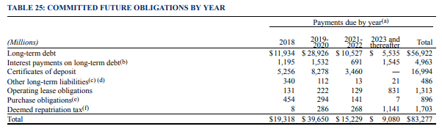
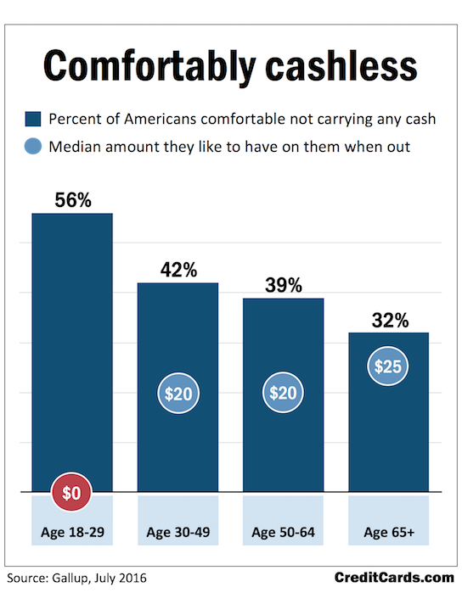
Use of technology to carry on the credit card business portrays a positive growth for Amex. Having Visa and MasterCard as its key competitors, and with the massive customer base, this strategy to integrate digital technology in the credit card business could in some years see AmEx catch up with the two giant in the business. However, the rate at which it has adopted technology especially in maximizing customer service to acquire a large customer base is still very low compared to Visa and MasterCard. AmEx is rapidly catching up with the immense use of digital technology in areas like data and analytics, fraud detection as well as customer acquisition through the use of web and machine learning models to enhance its marketing, (Logsdon 2016). Visa still remains a big competitor which makes it almost impossible for AmEx to catch up despite such technology advancement strategies and also increase its customer base among other factors of competition.

Appendixes
Appendix 1:
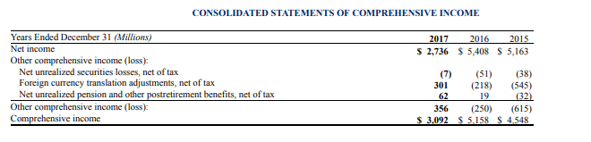
Appendix 2:
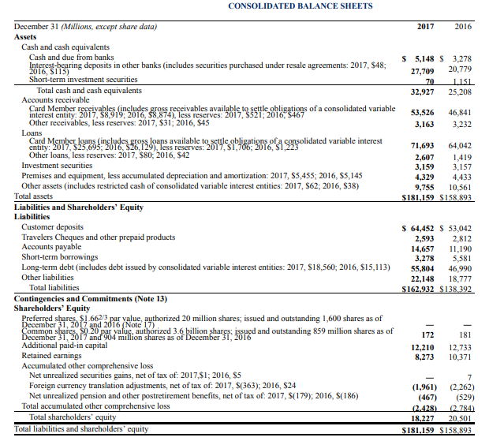
Appendix 3:
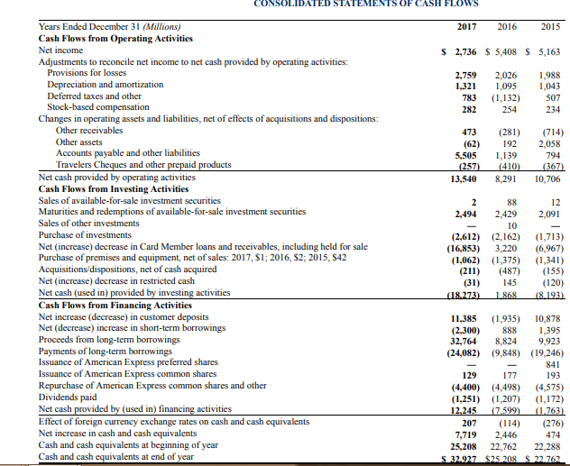
Appendix 4:
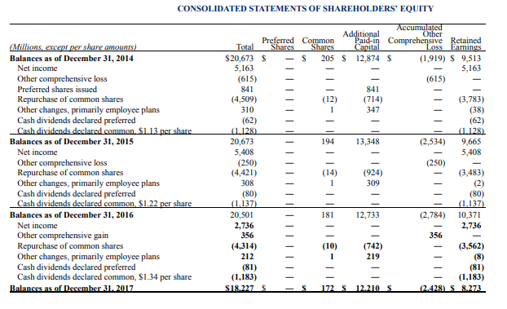

References
Conference Board, Inc. (2013). Helping Millennials Help You: Managing Your Young Workforce. New York: The Conference Board Inc.
Credit card news. (2014). Chicago: Faulkner & Gray Inc.
EBSCO Publishing (Firm). (2013). Barnes reports U.S Credit Card issuing Industry Report.
In Burke, R. J., Cooper, C. L., & In Antoniou, A. S. G (2015). The multi-general and ageing workforce: Challenges and opportunities.
Grning, Kuhn, R., & Montani, M. (2018). The strategic planning process: Analysis, options, projects.
Grant, R. M. (2016). Contemporary strategy analysis
Logsdon, Ruthie. American Express. Takoma Park, Md.: Azalea City Recordings, (2016). Sound
Recording
Wilson, J. D (2017). Creating strategic value through financial technology
https://www.iveybusinessjournal.com/publication/the-millenials/-a new generation of employees
https://www.ncbi.nlm.nhi.gov-Millenials in the workplace

